APPENDIX A
PHOTOGRAPHS TAKEN DURING JIV AT 24” OGBOINBIRI-OB/OB GASLINE AT OBOLOLI COMMUNITY, SOUTHERN IJAW L.G.A, BAYELSA STATE ON 14TH APRIL, 2024.
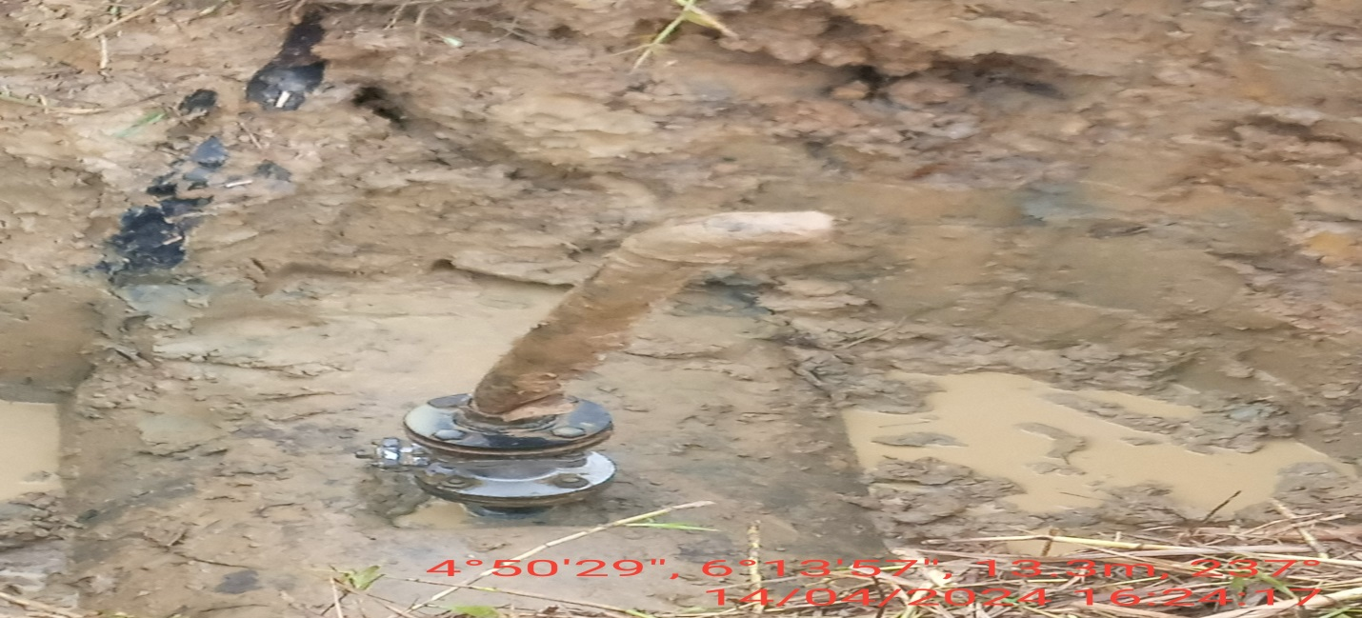
Fig. 1: 2” valve installed at 12 o’ clock position of the pipeline by unknown person(s).
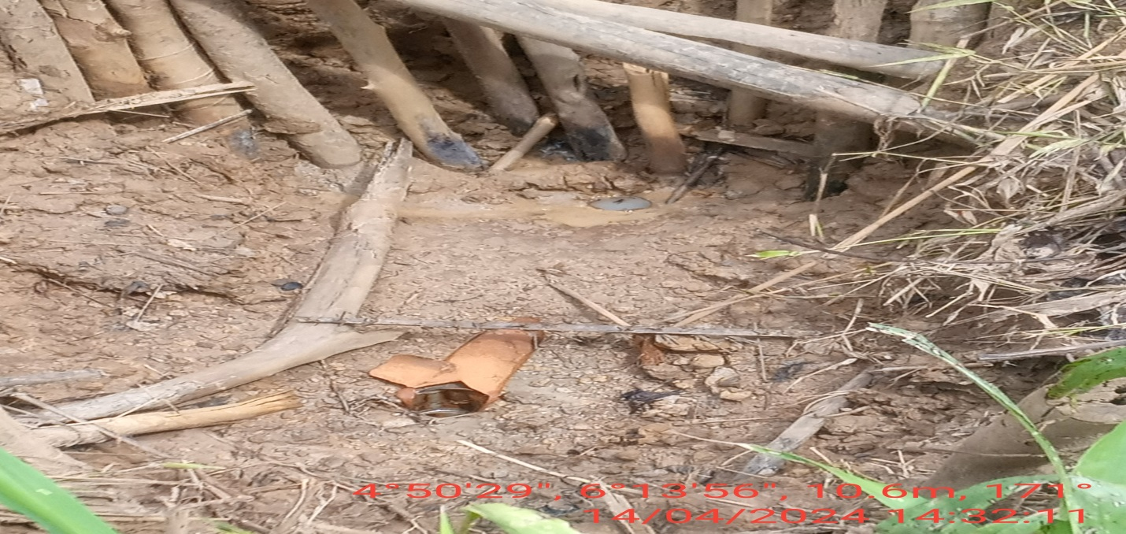
Fig. 2: The state of the environment on arrival of the JIT.

